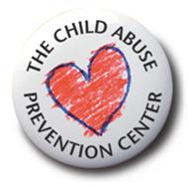
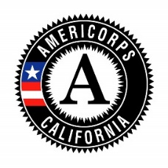
The Child Abuse Prevention Center

PUBLICITY RELEASE FORM
2020-2021 Program Year

Check the box for EITHER Section 1 or Section 2, then complete the bottom:
1. |  | I AUTHORIZE the agents listed below to use free of charge and without limitation, my name, photographic likeness and other possible identifying information for publicity, promotional or other purposes.  I hereby grant, assign and convey all rights, titles and interest I may have in any print, audio or filmed program material that I create and to any reproduction made in connection with my participation in the AmeriCorps Program with the following affiliated AmeriCorps agents:  - My assigned Service Site  - CaliforniaVolunteers (“CV”)  - Child Abuse Prevention Council of Sacramento, Inc. (“CAPC”)  - Corporation for National and Community Service (“CNCS”)  - Prevent Child Abuse California (“PCA CA”)
2. |  | I DECLINE to allow the agents listed above to use free of charge and without limitation, my name, photographic likeness and other possible identifying information for publicity, promotional or other purposes.
 | Member Print Name |  |  | Member Signature
 | Date

