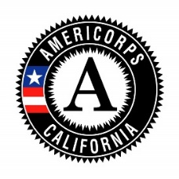
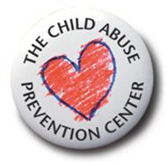
The Child Abuse Prevention Center

DECLARATION OF

HIGH SCHOOL EDUCATION
2020-2021 Program Year

Check the box for EITHER Section 1 or Section 2, then complete the bottom:
1. |  | I HAVE obtained a high school diploma or high school equivalency certificate.  I declare under penalty of law that the foregoing is true and correct.
2. |  | I HAVE NOT yet earned a high school diploma or high school equivalency certificate. I affirm that I have not dropped out of elementary or secondary school to enroll as an AmeriCorps participant. Further, I agree that I will not use any Segal AmeriCorps Education Award that I earn until I have obtained my high school diploma or equivalency certificate.
 | Member Print Name |  |  | Member Signature
 | Date

