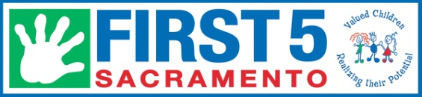
INFANT SAFE SLEEP
Participant Service Sheet
Date completed ____ /____/____ (month/day/year)

PARENT INFORMATION

First name: ___________________________________ Last name: ______________________________
Example: Monica Herrera-Lopez

Date of birth: _____/_____/________ (month\day\year) 3. Sex: Female Male

- City: ____________________________________ 5. Zip Code: _________________________________

- Race/Ethnicity: (Check all that apply)
 | Alaska Native/American Indian ₍₀₁₎ |  | Hispanic/Latino ₍₀₄₎ |  | Pacific Islander ₍₀₅₎ |  | Hmong ₍₀₇₎ |  | Multiracial ₍₀₉₎
 | Black/African American ₍₀₃₎ |  | Asian ₍₀₂₎ |  | White ₍₀₆₎ |  | Russian/Ukrainian ₍₀₈₎ |  | Other₍₁₀₎

- Language most comfortable with: (select ONLY one)
 | English ₍₀₁₎ |  | Cantonese ₍₀₃₎ |  | Vietnamese ₍₀₅₎ |  | Russian/Ukrainian ₍₀₇₎
 | Spanish ₍₀₂₎ |  | Mandarin ₍₀₄₎ |  | Hmong ₍₀₆₎ |  | Other ₍₀₈₎

- Relationship to child:
 | Mother ₍₀₁₎ |  | Father ₍₀₂₎ |  | Grandparent ₍₀₅₎ |  | Foster Parent ₍₀₇₎ |  | Other Relative ₍₀₉₎ |  | Other Adult (Not Related)₍₁₀₎

- How did you hear about this program?
 | Doctor/Clinic |  | CPS |  | FRC |  | Other community group |  | Home Visitor/Advocate
 | Family/Friend |  | Poster/Flyer |  | Website |  | Other _________________________________________

For program staff use only:
Participant Persimmony ID: ______________

Services received:
Safe Sleep Training

Crib

Notes:

Date Entered In Persimmony_____/____/_______ By ______

